Home Page

Slider 1 –Education is the passport to the future, for tomorrow belongs to those who prepare for it today. – Malcom X

Slider 2- Our kids are truly Global citizens. They deserve the education at par with Global standards.

Slider 3- Life is a roller-coaster ride. Don’t prepare the road for your kids. Prepare your kids for the road.

Slider 4 –EduEdge-One-on-one mentoring to your child to grasp any subject from K through 12.

Slider 5 – EduPro–A personalized orientation program for young adults to choose right career path.

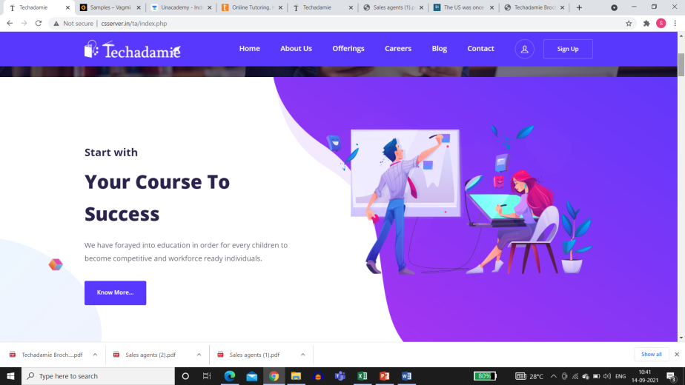

Who we are..

**Mentors to your child.**

We bring one of the most progressive plans & effective one-on-one method to help your child learn any subjects of any grade from K through 12.

Know More.

* 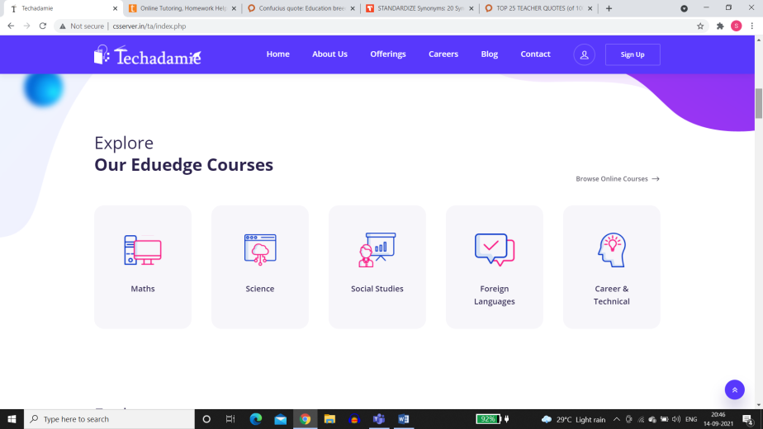

Our Offerings:

EduEdge:

Subjects Covered

General Math

General Science

Algebra

Geometry

Trigonometry

Calculus

Reading

Hindi

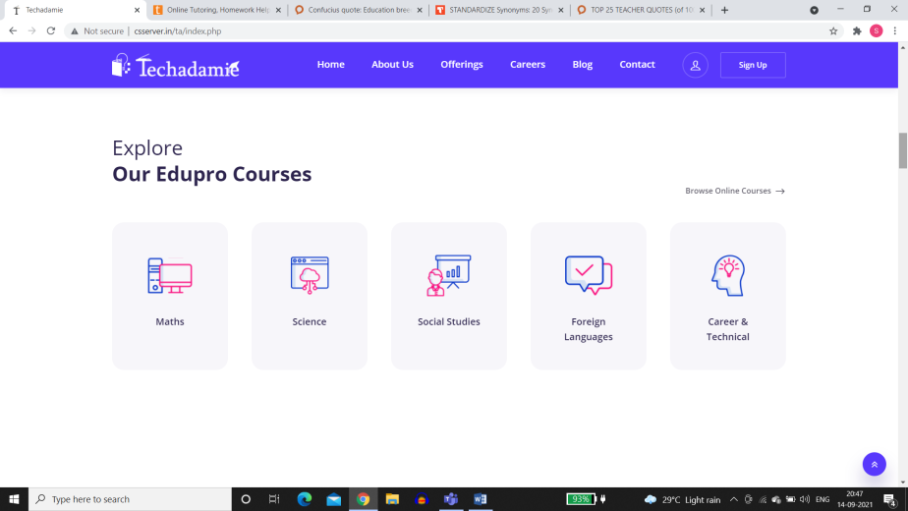

EduPro :

EduPro is a personalized orientation program wherein an expert mentor, based on your aptitude, will help you choose a right path for career growth. A career that utilizes your full potential. Expert, experienced and sought after career counsellors from India will assist you in this crucial process.

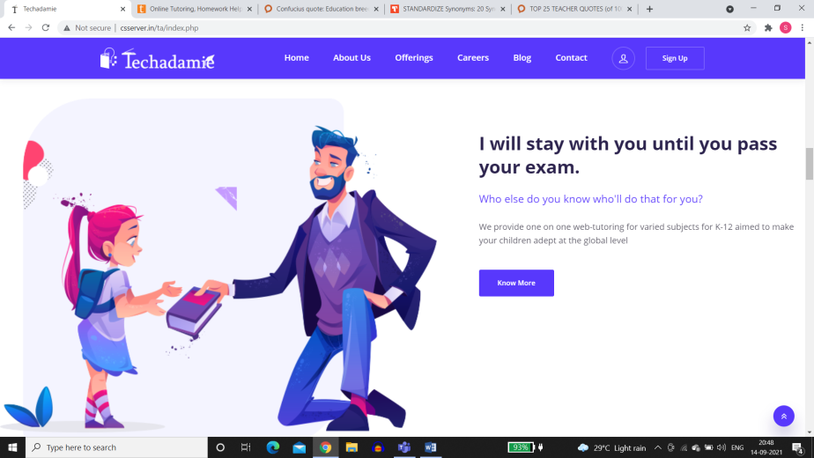

Handholding to prepare you to realize and utilize your full potential.

You are unique. And so will be your contribution to your own life and the society, as well.

Dear parents, children of impressionable age DO need a mentor and teacher to help shorten their learning curve, open their minds to new ideas and possibilities, identify development opportunities and help them to be future ready.

Know more / Take Charge, today.

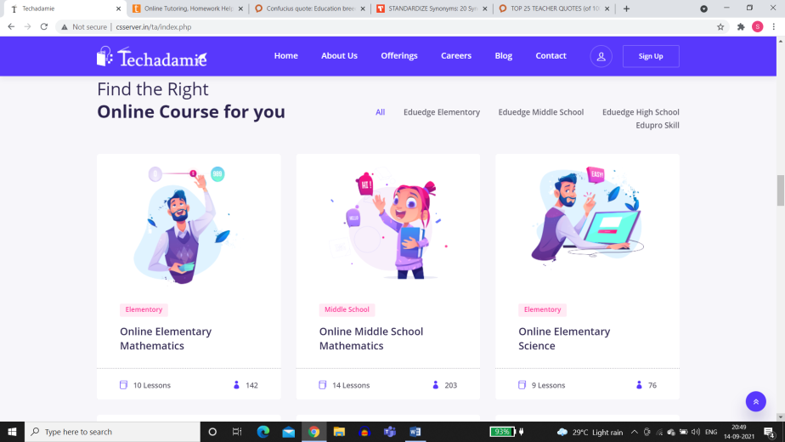

(This section won’t be there)

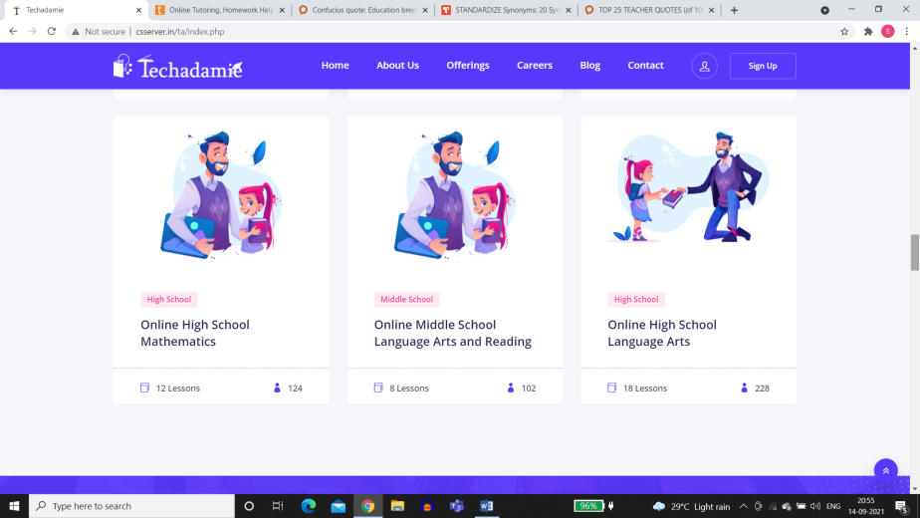

(This section won’t be there)



Teachers and Mentors.

Join us as our certified faculty.

If you take your mentorship responsibilities seriously, then *this* is the ideal platform for you to perform and be rewarded for it, in both money and satisfaction.

Know more / Get Started.

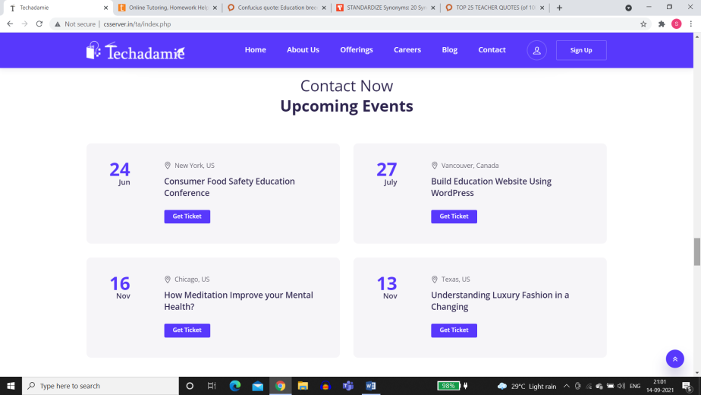

Events and happenings.



EduEdge – Simplified programs based on your unique needs, learning gaps and aspirations.

EduEdge Support:Help your child catch up in class by assisting with homework and clearing any doubts that may exist

EduEdge Excel: Help your child gain advanced knowledge of any subject that’s being taught in their class.

EduEdgeProsper :Shift gears to help your child meet educational standards of Indian education. This challenging program is highly in demand if you would want your child be able to attend elite colleges around the world.

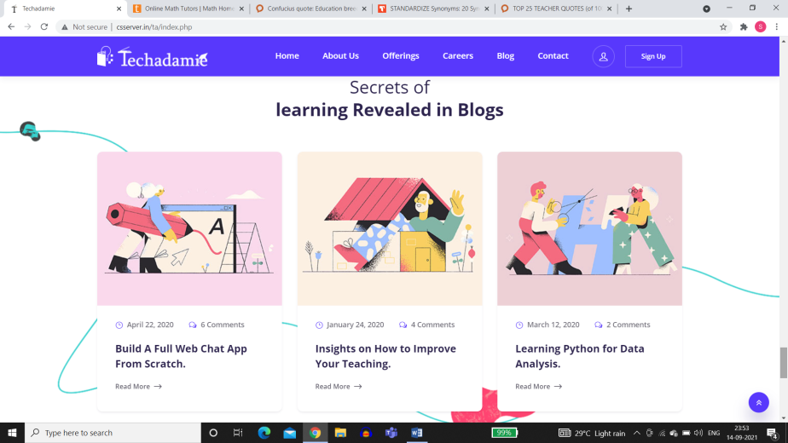

Blogs / Articles.

Stay in line with what’s happening in and around your academic circle.

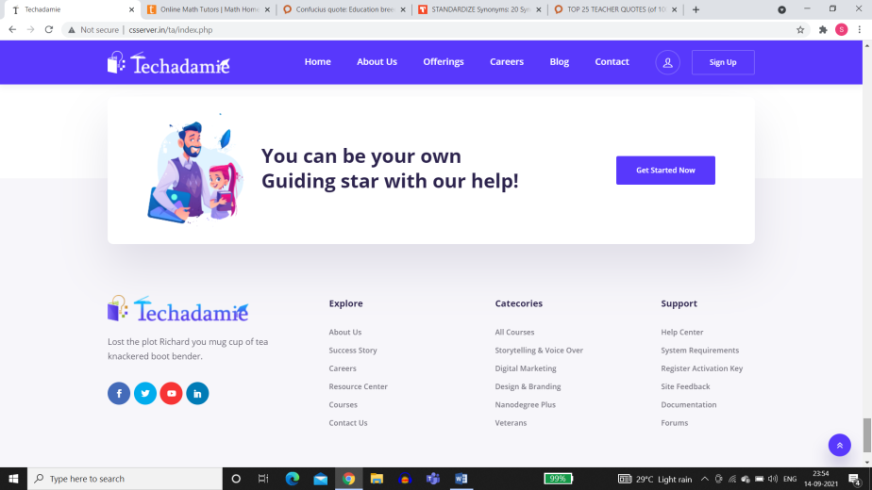

Refuse to be average. Don’t try to fit in, but Grow and amaze the world.

Get Started Now.